

Advanced Statistics
Team Members
Retaj Ali: 231005689
Rawan Atef: 231005789
Doha Mahmoud: 231005333
Mohanad Waleed: 231005430
Yassin Tamer: 231006879
Supervised by
Dr: Mohamed Fathy

Introduction
The Academic Analytics System is a smart educational platform that helps monitor and improve student performance using interactive dashboards and artificial intelligence technologies.
The system contains four main dashboards:
- Doctor Dashboard
- Parent Dashboard
- Student Dashboard
- Admin/Dean Dashboard
Each dashboard is designed for a specific user and provides important academic information and analytics.
The Doctor Dashboard helps instructors manage lecture sessions, monitor attendance, analyze student activity, and track classroom engagement during sessions.
The Parent Dashboard allows parents to follow their child’s academic progress, attendance, grades, and performance statistics in a simple and visual way.
The Student Dashboard helps students track their own grades, attendance, academic progress, and compare their performance with class averages.
The Admin/Dean Dashboard gives administrators full access to monitor the overall academic system, student statistics, and performance reports.
One of the main features of the project is the AI camera system connected using Python. During lecture sessions, the camera can:
- Detect student faces
- Recognize students
- Analyze emotions
- Monitor student activity and engagement
- Track attendance
- Detect participation and questions asked

Tools Used
Programming Languages
- Python
- R
- SQL
- Dart
Frameworks & Technologies
- Flutter
- APIs
Python Libraries
- OpenCV
- Shiny
- DeepFace
- Pandas
- NumPy
- Plotly
- DT Tables
Database
- SQL Database
- CSV file
AI & Computer Vision
- Face Detection
- Emotion Recognition
- Activity Monitoring
- Attendance Tracking
- Hand Marks

Project Overview
The Academic Analytics System is a smart educational platform that helps improve academic monitoring and student performance analysis using dashboards and artificial intelligence technologies. The system allows doctors, parents, students, and administrators to access important academic information through interactive dashboards and visual analytics. It combines attendance tracking, student performance monitoring, classroom engagement analysis, and AI camera technologies to create a smarter educational environment.

Doctor Dashboard
The Doctor Dashboard is designed to help instructors manage lecture sessions and monitor student performance during classes. It allows doctors to track attendance, analyze student activity, monitor classroom engagement, and filter session data based on course, week, day, and class time. The dashboard also provides detailed student reports, charts, and performance statistics to help instructors understand student behavior and academic progress more effectively.

Parent Dashboard
The Parent Dashboard helps parents follow their child’s academic progress in a simple and visual way. Parents can view grades, attendance, GPA, subject scores, class rankings, and academic statistics. The dashboard also provides notifications and recommendations, such as attendance warnings or subjects that need improvement, helping parents stay updated with their child’s educational performance.

Student Dashboard
The Student Dashboard allows students to monitor their own academic performance and progress. Students can track their grades, attendance, GPA, and subject performance using interactive charts and analytics. The dashboard also compares student performance with class averages and provides academic insights that help students identify weak areas and improve their overall results.

Admin / Dean Dashboard
The Admin or Dean Dashboard gives administrators full access to monitor the overall academic system. It displays college statistics such as total students, average GPA, attendance rates, pass rates, and performance analytics. The dashboard also helps administrators monitor doctor performance, analyze course statistics, identify at-risk students, and review overall educational performance across the institution.
AI Camera System
The project includes an AI-powered camera system connected using Python and computer vision technologies. During lecture sessions, the camera system detects and recognizes student faces, analyzes emotions, tracks attendance, and monitors classroom engagement. It can also measure student activity, participation, and the number of questions asked during sessions, helping instructors better understand student interaction and focus levels.
Login page
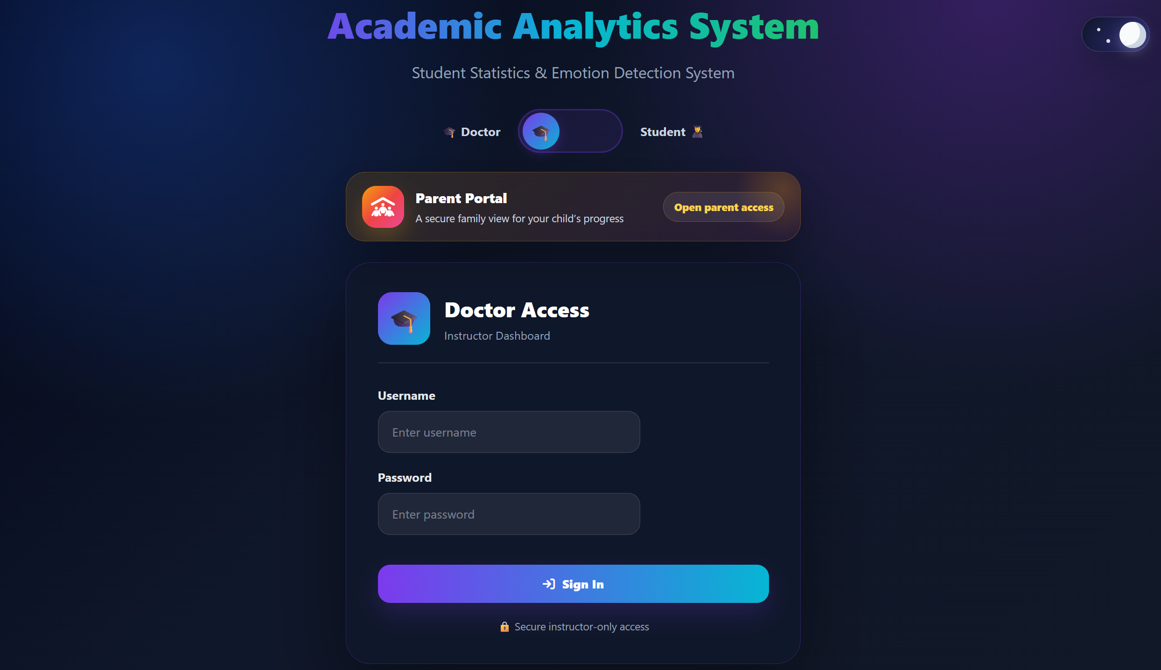

Doctor Dashboard
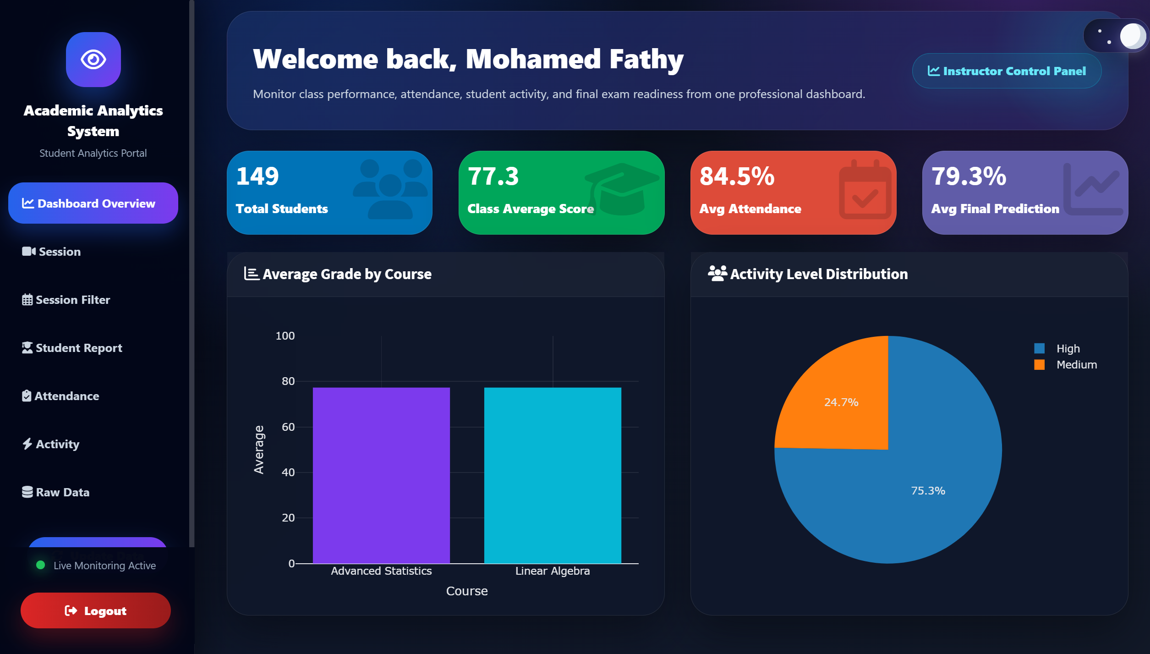
Admin Dashboard
